What to do today
IMPORTANT Parent or Carer – Read this page with your child and check that you are happy with what they have to do and any weblinks or use of internet.

1. Chose a view and write about it
- Look carefully at Sea Views.
- Which of these seas would you most like to watch? Why?
- Write a careful description of what you would see, smell and feel.

2. Read and think about a poem
- Read Doing Nothing Much.
- Read and think about the Poetry Questions. Write some of your answers in clear sentences.

3. Compare two poems
- Read Maggie and Millie and Molly and May. Then read Black Pebble.
- Answer the Seaside Poem Questions to help you to understand the poems.
- Fill in the Compare Frame, to show what is similar about the two poems.

Well done. Read your Compare Frame to a grown-up. Do they agree with the thing that you said was most similar about the two poems?

Try the Fun-Time Extras
- Pick your favourite of the three poems:
- Can you make an illustration for it?
- Can you learn all or some of it off-by-heart?
- Can you practise reading it aloud until you are really confident?
- Can you record and share your reading of the poem?
- Can you write your own poem about the sea?

Sea Views
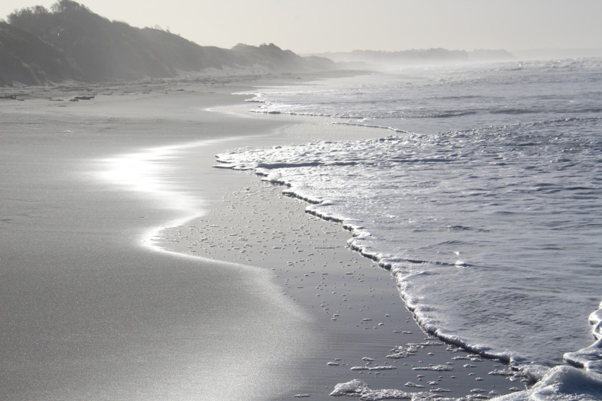
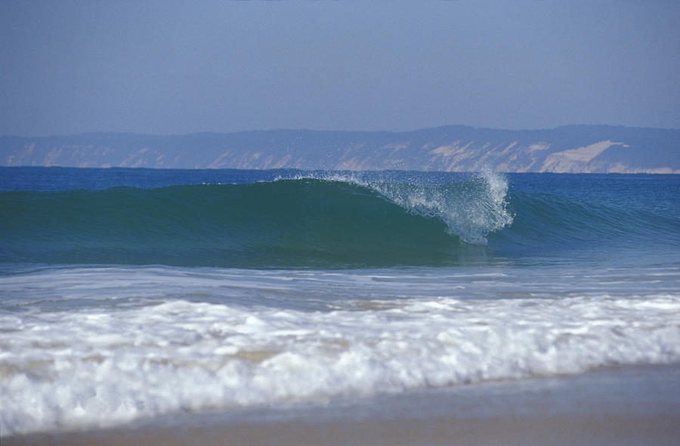 | 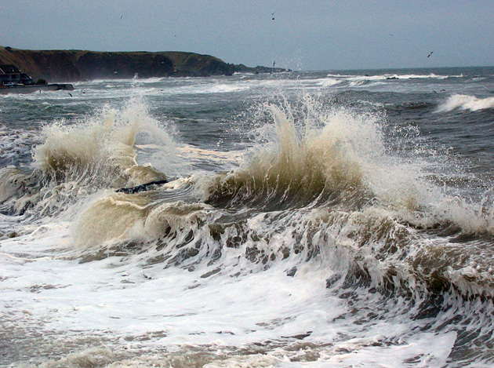

Doing Nothing Much

I could potter for hours on a lonely beach
Picking pebbles to roll in my hand,
Wondering where will the next wave reach,
Writing my name in the sand

Near the tumbling weir, where the hawthorn’s pink.
I could sit for hours in a trance
Watching the water stream to the brink
And the white foam pound and dance.

Or high on a headland find me,
While a seagull wheels and dips,
Gazing for hours out to sea
At islands and smudges of ships.

by Eric Finney

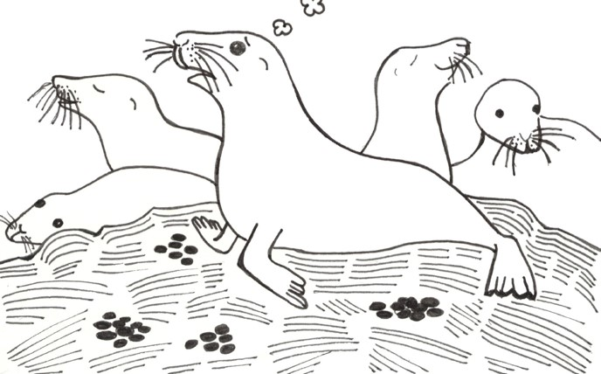

Poetry Questions

What do you like about the poem? Is there anything you dislike? What does it remind you of? How does it make you feel?
What patterns can you find? Is there any rhyme, alliteration or assonance? Is anything repeated?
What interesting words or phrases can you find? What do they mean? Are there any metaphors or similes? Are there any vivid descriptions?

Maggie and Milly and Molly and May

maggie and milly and molly and may
went down to the beach (to play one day)

and maggie discovered a shell that sang
so sweetly she couldn't remember her troubles, and

milly befriended a stranded star
whose rays five languid fingers were;

and molly was chased by a horrible thing
which raced sideways while blowing bubbles: and

may came home with a smooth round stone
as small as a world and as large as alone.

For whatever we lose (like a you or a me)
it's always ourselves we find in the sea

by E.E. Cummings
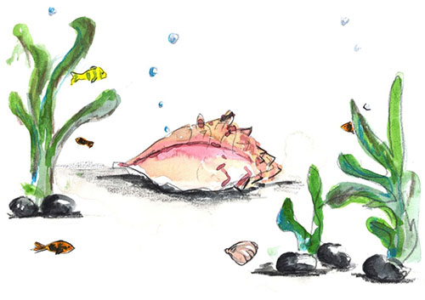

The Black Pebble

There went three children down to the shore
Down to the shore and back;
There was skipping Susan and bright-eyed Sam
And little scowling Jack

Susan found a white cockle shell,
The prettiest ever seen,
And Sam picked up a piece of glass
Rounded and smooth and green.

But Jack found only a plain black pebble
That lay by the rolling sea,
And that was all that ever he found;
So back they went all three.

The cockle shell they put on the table,
The green glass on the shelf,
But the little pebble that Jack had found
He kept it for himself.

by James Reeves

Seaside Poem Questions

Who visits the seaside in the poem?

What do they find at the seaside?

What do they do when they come home?

Has going to the seaside changed them?

Compare Frame

There are several ways in which ….

and …. could be said to be similar.

The first way that they are alike is that they are both …

Another similarity is that they ….

A further feature they have in common is ….

Finally, they both ….

I think the most significant similarity is …

because…

from Speaking Frames by Sue Palmer

