What to do today
IMPORTANT Parent or Carer – Read this page with your child and check that you are happy with what they have to do and any weblinks or use of internet.

1. Read a poem
- Read Winter.
- Write on the text to show the parts of the poem that you particularly like, any patterns that you can see and any questions or puzzles that you find.

2. Practise Adverbials
- Use the Revision Card to remind yourself about adverbials.
- Practise using adverbials by writing sentences with a fronted adverbial that could go with the months of the year.
- Write your sentences on Month Poem Idea. Challenge yourself to write at least 6 sentences. Adverbial Ideas and Preposition Examples might be helpful.

3. Choose a favourite poem
- Pick your favourite month or the month of your birthday. Can you find a poem that would match this month well? You could use one of the poems we have read, or you could search online. Start with this website: https://childrens.poetryarchive.org/
- When you have found your poem, write all of it or some of it out very carefully.

Try the Fun-Time Extra
- Can you illustrate your favourite poem?
- Can you record yourself reading it and send the recording to someone else?

Winter
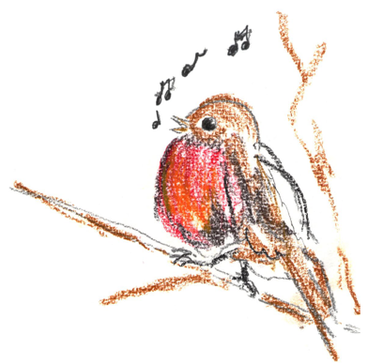

Clouded with snow
The cold winds blow,
And shrill on leafless bough
The robin with its burning breast
Alone sings now.

The rayless sun,
Day’s journey done,
Sheds its last ebbing light
On fields in leagues of beauty spread
Unearthly white.

Thick draws the dark,
And spark by spark,
The frost-fires kindle, and soon
Over that sea of frozen foam
Floats the white moon.

by Walter de la Mere

Revision Card – Adverbials

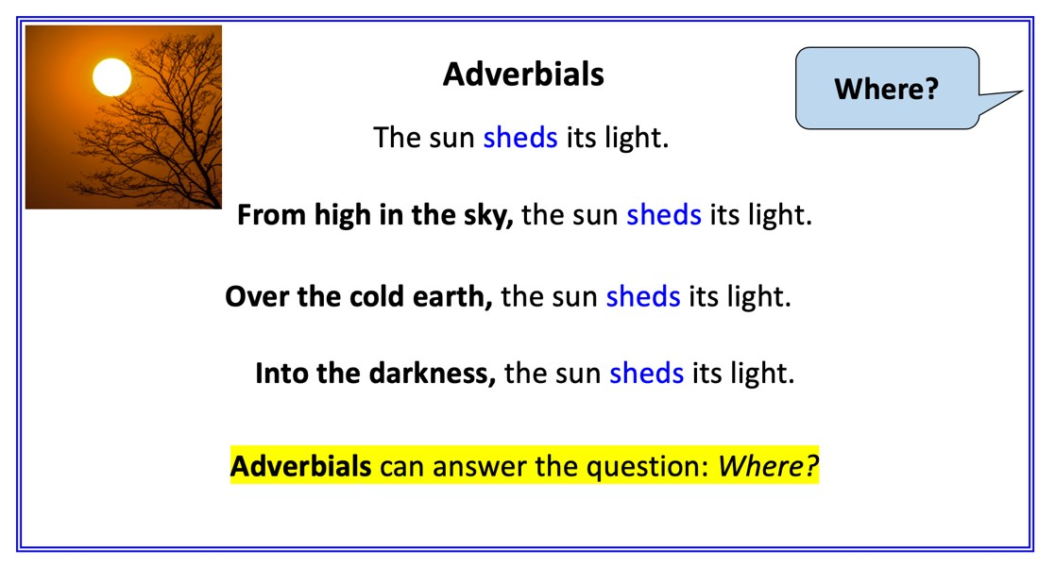 | 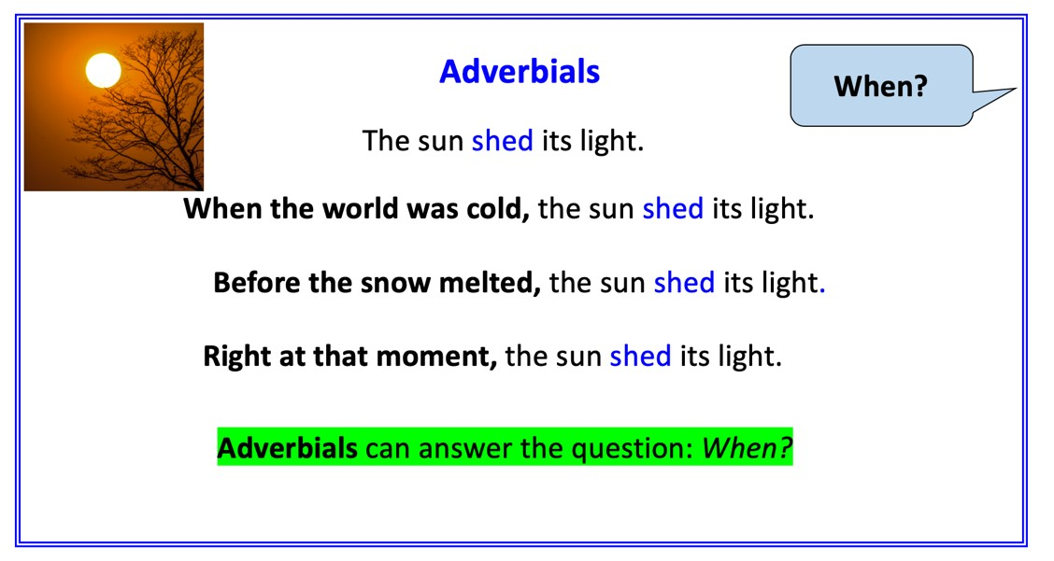
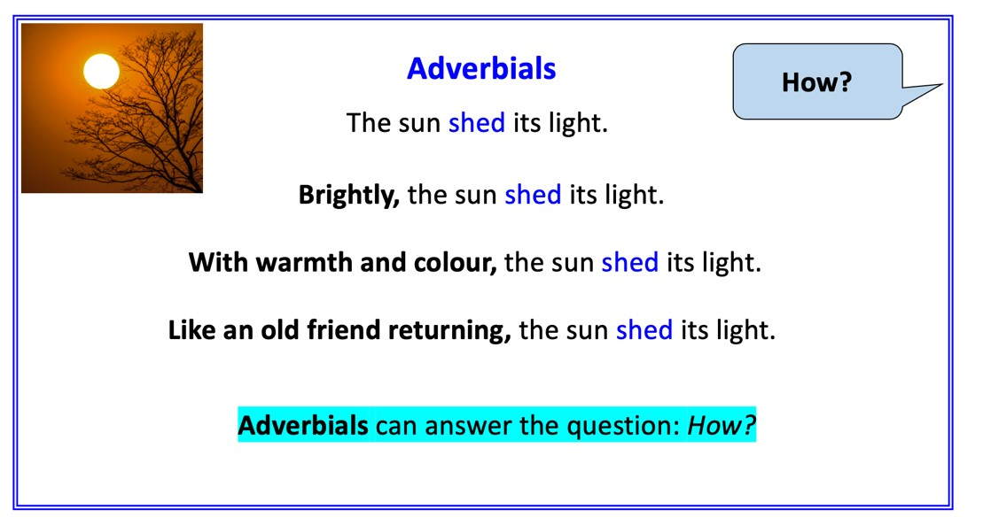 | 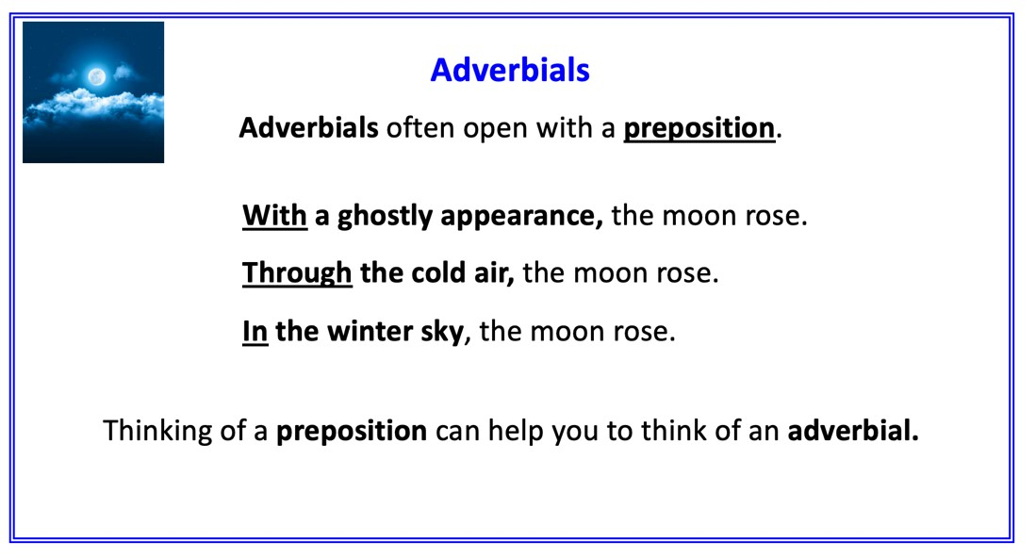

Month Poem Ideas

Write a sentence with a fronted adverbial to match the month of the year.

J
F
M
A
M
J
J
A
S
O
N
D

Adverbial Ideas

In the dark of the night,

Curled up and hidden,

Frolicking and bleating,

Wild and noisy,

Splashing and jumping,

Wet and miserable,

Brightly shining,

Roaring and speeding,

Cold and fresh,

Lined up on the wire,

Preposition Examples

above
after
against
below
beneath
beyond
on
round
under
amongst
into
amidst
My favourite poem

Write all or part of your favourite poem carefully here.

