- What is the purpose of this app?
_____________________________________________________________________________________________________________________
- What can you tell me about the text/font on the app?
_____________________________________________________________________________________________________________________
- Tell me something positive about the layout of the app?
_____________________________________________________________________________________________________________________

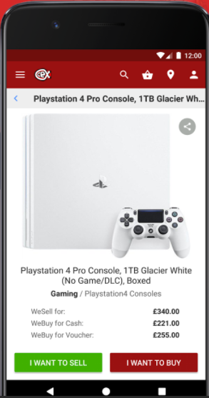
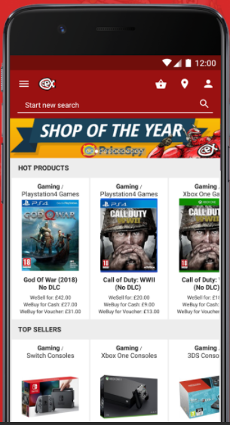
- What consistent features can you see on both screenshots?
_____________________________________________________________________________________________________________________
- What is the house style of this app?
_____________________________________________________________________________________________________________________

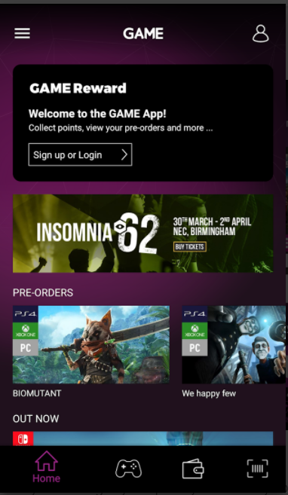
- How is this app similar to both apps pictured above?
______________________________________________________________________________________________________________________________________________________________________________
- How will the user interact with this app?
______________________________________________________________________________________________________________________________________________________________________________

Task
GameExchange123 is an online company that operates in the UK. They buy used computer games and then sell them to make a profit. Users log in to the website, enter details of the games that they want to sell and are then offered a buying price. If they are happy with the price, they will post their games and the money will be transferred to their bank account.
They want to set up a smartphone app to keep up with their competitors. The app should provide the same functionality as their website. They have asked you to design and develop the user interface of their new app. Create 3 different homepages below of what the app may look like. The company colours are Black & Blue.
Design 3
Design 2
Design 1

The homepage should welcome the user to the app and display a list of games that are currently high in demand. You may use the internet to look for current popular games or you can make up the games. There should be a search facility to allow the user to enter the name of a game they want to search for and the results will be displayed on the screen.
FIT (Feedback Improvement Task to be completed in purple)

Use the blank phone of the left to design the home page of the app GameExchange123.
It should show the following.
- A welcome message.
- A list of games that are currently high in demand.
- A search facility so a user can look up a game.
Remember – to use the company colours Black and Blue.

Use the second phone to draw what the app will look like after a user has entered a game to search for.
I.e. imagine you have searched for a game and pressed search what will the app look like now.

Remember – to use the company colours Black and Blue.

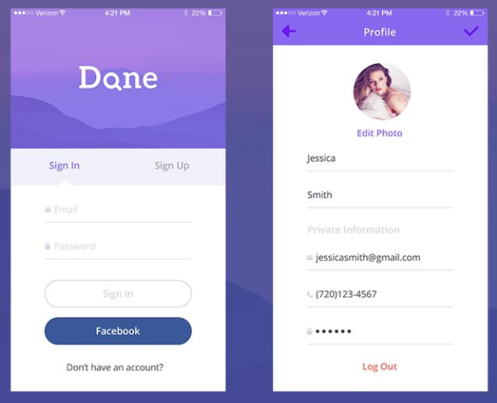

Task 3
This page allows users to enter their username and password. Once they have successfully done this, they will be shown their account information. They should be able to view and update their personal details. Complete the labels using the following sentences.
- Allows user to create account.
- User should enter a password
- User should enter username/email.
- User can change profile photo.
- Users into is displayed.
- User can confirm changes.

Task 2
Use the blank phones to design the Log-in/sign-up page for GameExchange123.
Remember – to use the company colours Black and Blue.

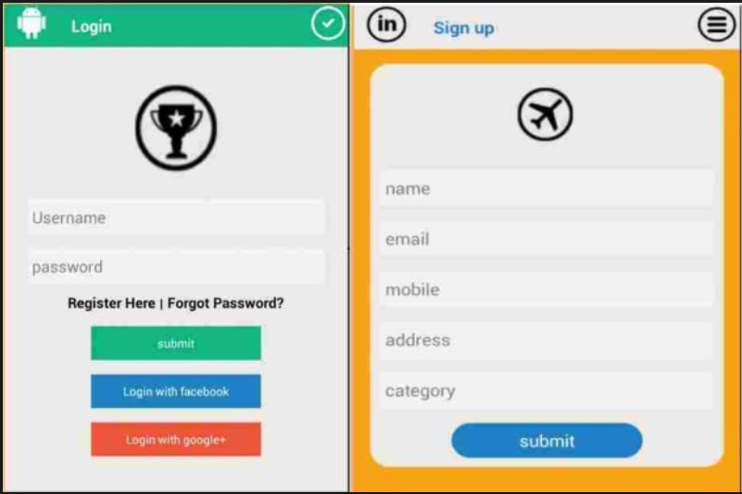
If users do not already have an account, then there should be a link to a form allowing the user to sign up and create an account (see example). The user should be able to enter their:
- first name
- surname
- address
- postcode
- telephone number
- email address
- What type of games console they have.

FIT (Feedback Improvement Task to be completed in purple)

Requirments for Buying page
This screen allows users to enter details of the game they want to sell. They should be able to enter:
- the barcode number
- the condition of the box/packaging (i.e. poor, satisfactory, good, excellent)
- if the user manual is still available (i.e. yes, no)
- the condition of the disk (i.e. poor, satisfactory, good, excellent)
Suitable outputs and prompts should be given to support the user when entering these details. When all these details have been entered, the app should then display a buying price. The user can then accept or decline. If the user accepts the buying price, then a code should be generated and displayed on the screen for them to send with their game in the post.
Screen 1
Screen 2
Task – Sketch how the buying page will look for the app GameExchange123 using the requirements above.
Remember – to use the company colours Black and Blue.

